**Are the teeth cracked?**

**-- Binary classification of teeth conditions via functional data analysis**

Consultant: Wei Angel Huang

Clients: Dr. Beatriz Paniagua, Dr. Jared Vicorya, Kitware Inc, Carrboro, NC

Professors: Dr. Steve Marron, Dr. Perry Haaland

March 4th, 2021

**Abstract**

Microfractures (cracks) are the third most common cause of tooth loss in industrialized countries. If not detected early, microfractures continue to progress and can cause sharp pain and result in tooth loss. To improve early detection of cracks in a non-invasive, data-driven way, a new imaging analysis algorithm was developed in combination with the high resolution cone beam computed tomography (hr-CBCT). To compare its performance with the traditional micro-CT, we analyzed two datasets derived from micro-CT and hr-CBCT, both containing cracked teeth as well as healthy teeth. Using functional data analysis, we found that for micro-CT, cracked teeth and healthy teeth are hardly distinguishable due to the high false positives of cracks detected. However, for hr-CBCT, there are much fewer false positives and the data from cracked teeth and healthy teeth shows significant separation. This result supports that the hr-CBCT pipeline outperforms the micro-CT in early detection of cracked teeth which potentially lead to earlier treatment and longer tooth retention.

**Executive Summary**

An overview of the major findings and their corresponding subsection identifier is as follows:

* The distributions of number of “cracks” in cracked and healthy teeth are distinct in hr-CBCT dataset but mostly overlapping in micro-CT dataset (Result 1).
* The distribution of crack sizes for cracked vs. healthy teeth are more separable in hr-CBCT dataset than micro-CT dataset, and is better visualized in logarithmic scale (Result 2).
* Hr-CBCT but not microCT shows good separation of teeth conditions in principle component directions (Result 3).
* Hr-CBCT but not microCT shows separation of means between the two teeth conditions in later quantiles of data (Result 4).
* Quantitative testing reveals a significant separation of the two teeth conditions using hr-CBCT but not microCT (Result 5).

**Introduction**

Cracked teeth are the third most common cause for tooth loss in industrialized countries.1 Once crack develops, it is colonized by bacteria, which can cause pulpal and periapical disease2, both of which cause intense pain which is the most common reason for emergency dental care3. If left undetected, cracks continue to progress and ultimately result in tooth loss.

However, cracked teeth are extremely hard to detect, especially during early stage. 2D intraoral radiographs (i.e. X-rays) and cone beam computed tomography (CBCT) scans are imaging tools used to detect cracks. CBCT performs better than 2D intraoral radiographs by capturing the 3D structures, but still has its limitations. To this end, the client combined high-resolution CBCT (hr-CBCT) with advanced image analysis and machine learning in the hope of devising a better tool for early detection of cracks in a non-invasive, data-driven way. The goal of this report is to evaluate the data derived from this pipeline on its ability to separate out cracked teeth from healthy teeth. Another dataset derived from micro-CT was also evaluated using the same pipeline as a baseline comparison.

**Method**

*Data*

Data was provided by Jared Vicory, Kitware Inc, Carrboro. There are two datasets, one from microCT (n=45 teeth, 31 cracked and 14 healthy), another from synthetic hr-CBCT (n=25 teeth, 19 cracked and 6 healthy). Detailed description of data generation methods are here4. In short, there are 45 extracted human premolars (first and second molars) in the microCT dataset. 31 teeth were randomly selected to undergo simulated stress microfractures while the rest 14 teeth were used as healthy controls. All the teeth were then examined by two masked investigators to mark the presence(=1)/absence(=0) of superficial micro cracks in each tooth. It was confirmed that the simulated stress reliably induces cracks which mimics the common clinical presentations of stress induced dental cracks.

Another set of teeth data were generated using synthetic hr-CBCT5 without the smoothing filters. The smoothing filters were used in normal hr-CBCT for better perception of gross tooth structure but destroys fine features like microfractures. Since an hr-CBCT dataset without filter is not available, the data was synthetically generated for hr-CBCT.

In both datasets, each tooth data is represented in a vector of “putative crack sizes”, sorted from the biggest crack (i.e. largest number of connected voxels) to the smallest (i.e. fewest number of connected voxels). Each tooth can have different number of cracks (i.e. features) and each crack can have various sizes (i.e. number of connected voxels).

*Functional data analysis*

Functional data analysis (FDA) is an extension of multivariate analysis that is suitable to analyze the variation in a population of curves or distributions. Due to the fact that each of our data sample is a vector of crack sizes that are sorted from largest to smallest, it can be viewed as a curve. Thus, we chose FDA as our main analytical method. The FDA package used in this analysis was developed by Dr. Steve Marron6.

The analysis scripts were written in Matlab 2020a and can be found in https://github.com/angelvv/STOR765_Spring2020_Angel_Huang.

**Result**

Due to the fact that the two datasets were generated in different settings and have different sample sizes, no direct quantitative comparison was made between the two datasets. Instead, the focus of this study is to evaluate the performance of hr-CBCT pipeline, with MicroCT serving as a qualitative baseline comparison. The exact same analysis pipeline was applied to both datasets. In fact, to reduce the potential bias in analysis, the consultant was kept blinded to the conditions of the datasets during the analysis and was not aware of the comparison until the end of the project.

1. *Hr-CBCT shows distinct distributions of number of “cracks” between teeth conditions, whereas microCT does not*

Since teeth samples have different number of putative “cracks” (i.e. features), we first visualized the distribution of number of “cracks” (Fig. 1). For microCT dataset, cracked teeth have a broader spread of number of “cracks” (between 315 and 1000) than healthy teeth (between 408 and 751). But there is a big overlapping of distribution between cracked and healthy teeth, indicating that many “cracks” are probably false-positives in the healthy teeth. For hr-CBCT, cracked teeth have generally a much higher number of “cracks” (between 47 and 948) than healthy teeth (between 6 and 148). This makes more sense as real cracks are normally long and contains more voxels.

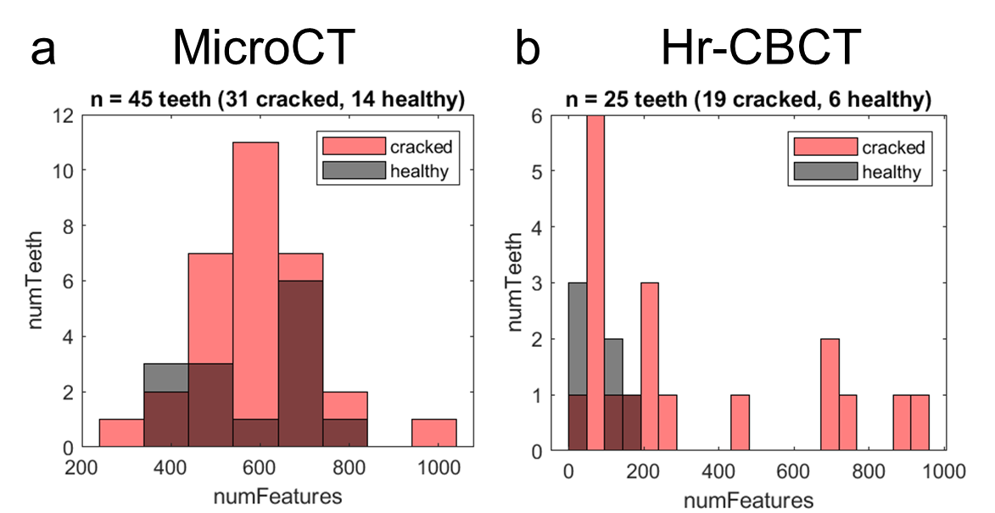

*Figure 1. Distribution of number of “cracks” (i.e. features) for microCT (a) and hr-CBCT (b). Hr-CBCT shows bigger separation of distribution between cracked teeth (red) and healthy teeth (gray).*

1. *The distribution of crack sizes for cracked vs. healthy teeth are more separable in hr-CBCT dataset than in micro-CT dataset*

To further visualize the distribution of crack sizes in each tooth, we plotted distribution of crack sizes for both microCT and hr-CBCT datasets (Fig. 2). Since the largest crack size is normally in the hundreds and the smaller crack sizes are in the single or double digits, logarithmic scale of data provides better visual separation across this wide range of scales (Fig. 2 bottom). As a result, we will use logarithmic scale of data for further analysis. In addition, we compared the largest “crack” in each dataset since the larger the “crack”, the more likely it resembles a real crack other than noise or artifact. For microCT, the range of the largest “crack” in cracked teeth (range from 125 to 1336 voxels) is a little broader than that of control teeth (range from 149 to 1210 voxels), suggesting a higher variability in cracked teeth samples. For hr-CBCT, a more distinct difference is seen -- the range of the largest “crack” in cracked teeth (range from 10403 to 1151856) is much right-shifted than healthy teeth (range from 14 to 66927). This shows that hr-CBCT is more likely to identify larger “cracks” (even in healthy teeth) but also better at identifying real cracks. This can also be seen in the separation of the first feature of two teeth conditions (Fig. 2 bottom).

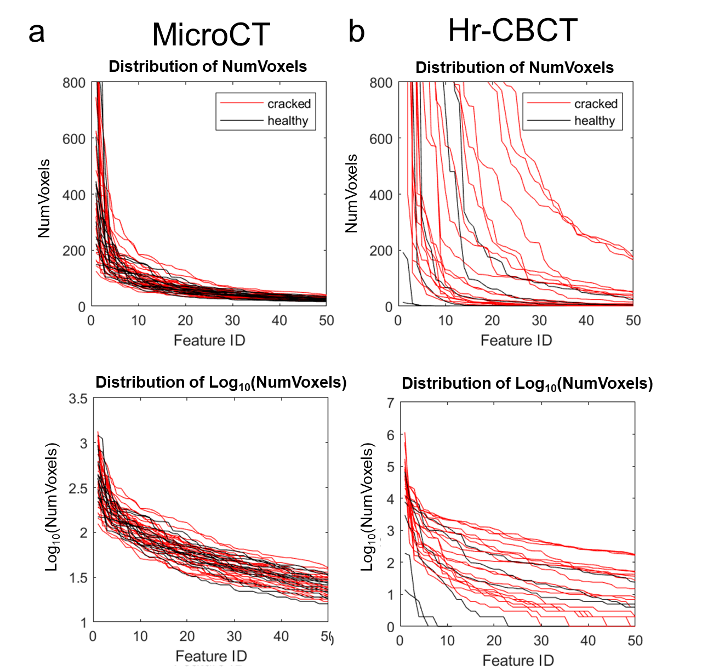

*Figure 2. Distribution of crack sizes for microCT (a) and hr-CBCT (b) for the largest 50 “cracks” in each tooth. For each dataset, the top plot displays the raw data and the bottom plot displays data in logarithmic scale. For both datasets, logarithmic scale provides better visualization of the distribution. Hr-CBCT shows qualitatively better separation of crack-size distributions between cracked and healthy teeth.*

1. *Hr-CBCT shows better separation of teeth conditions in principal component directions*

For data that contains a large number of features like in our datasets, Principal Component Analysis (PCA) is a great way to extract the key features that correspond to lower dimensional representations of the data. In FDA, it helps to visualize the difference between distributions. In Figure 3 top row, we plotted the data, its mean, mean residual and the R2 of the residual. It is interesting to see that for microCT, the shape of the data is mostly determined by the mean (98%) whereas for hr-CBCT, the shape of the data is a feature of the mean (57%) as well as the variability about the mean (43%). We then extracted first four principle components for each dataset (Fig. 3 row 2-5). For microCT, none of the PC direction show good separation between the two teeth conditions as shown by the overlapping black and red colors. For hr-CBCT, PC1 (explains 91% of the variance) seems to extract the vertical shift of data, and other PCs exact more of the dynamic of the distribution. In addition, in both PC1 and PC4 dimensions, healthy teeth correspond to higher PC scores than cracked teeth in general.

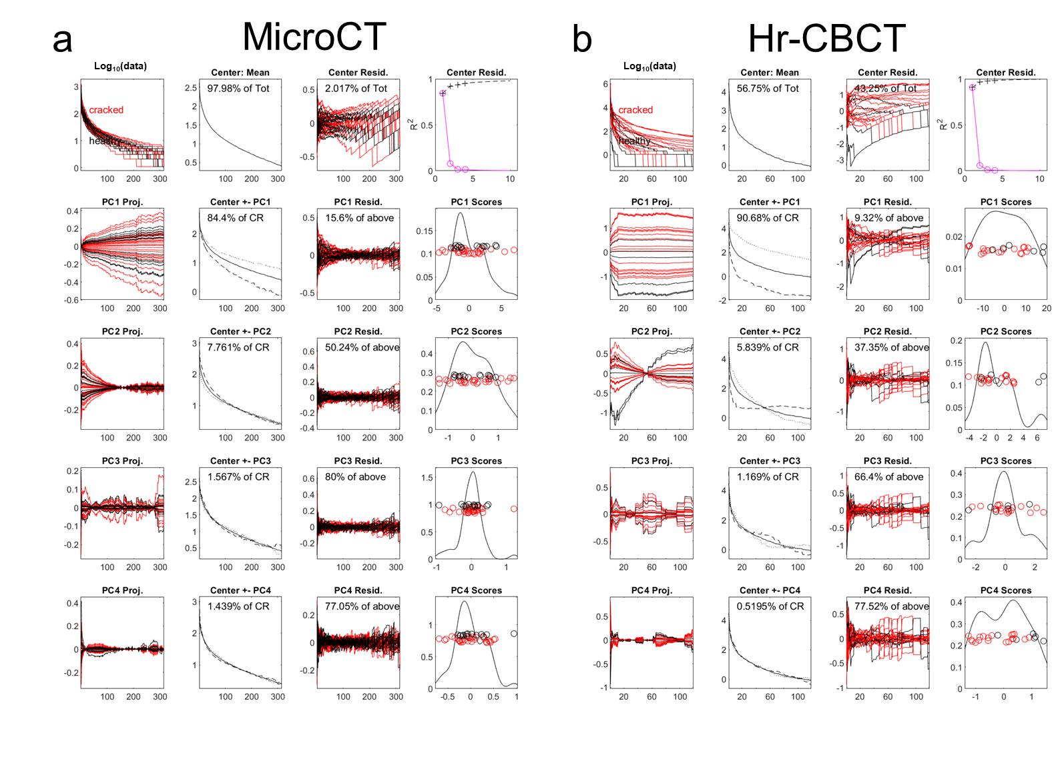

*Figure 3. Visualization of modes of variation using principal component analysis for microCT (a) and hr-CBCT (b). Each line in column 1 and 3, and each dot in column 4 represents a tooth sample, either cracked (red) or healthy (black). In hr-CBCT but not micro-CT, there is some separation between cracked vs. healthy teeth in the principal component directions.*

Since multiple PC directions showed promising separation of teeth condition, we further plotted hr-CBCT data on combinations of PC directions to see if it will improve the separation (Fig. 4). As expected, data projected onto a combination of PC1 and PC4 directions (first row, last column) shows improved separation between teeth conditions compared to that onto a single PC direction, although no strong clustering was observed probably due to small sample sizes (Fig. 3).

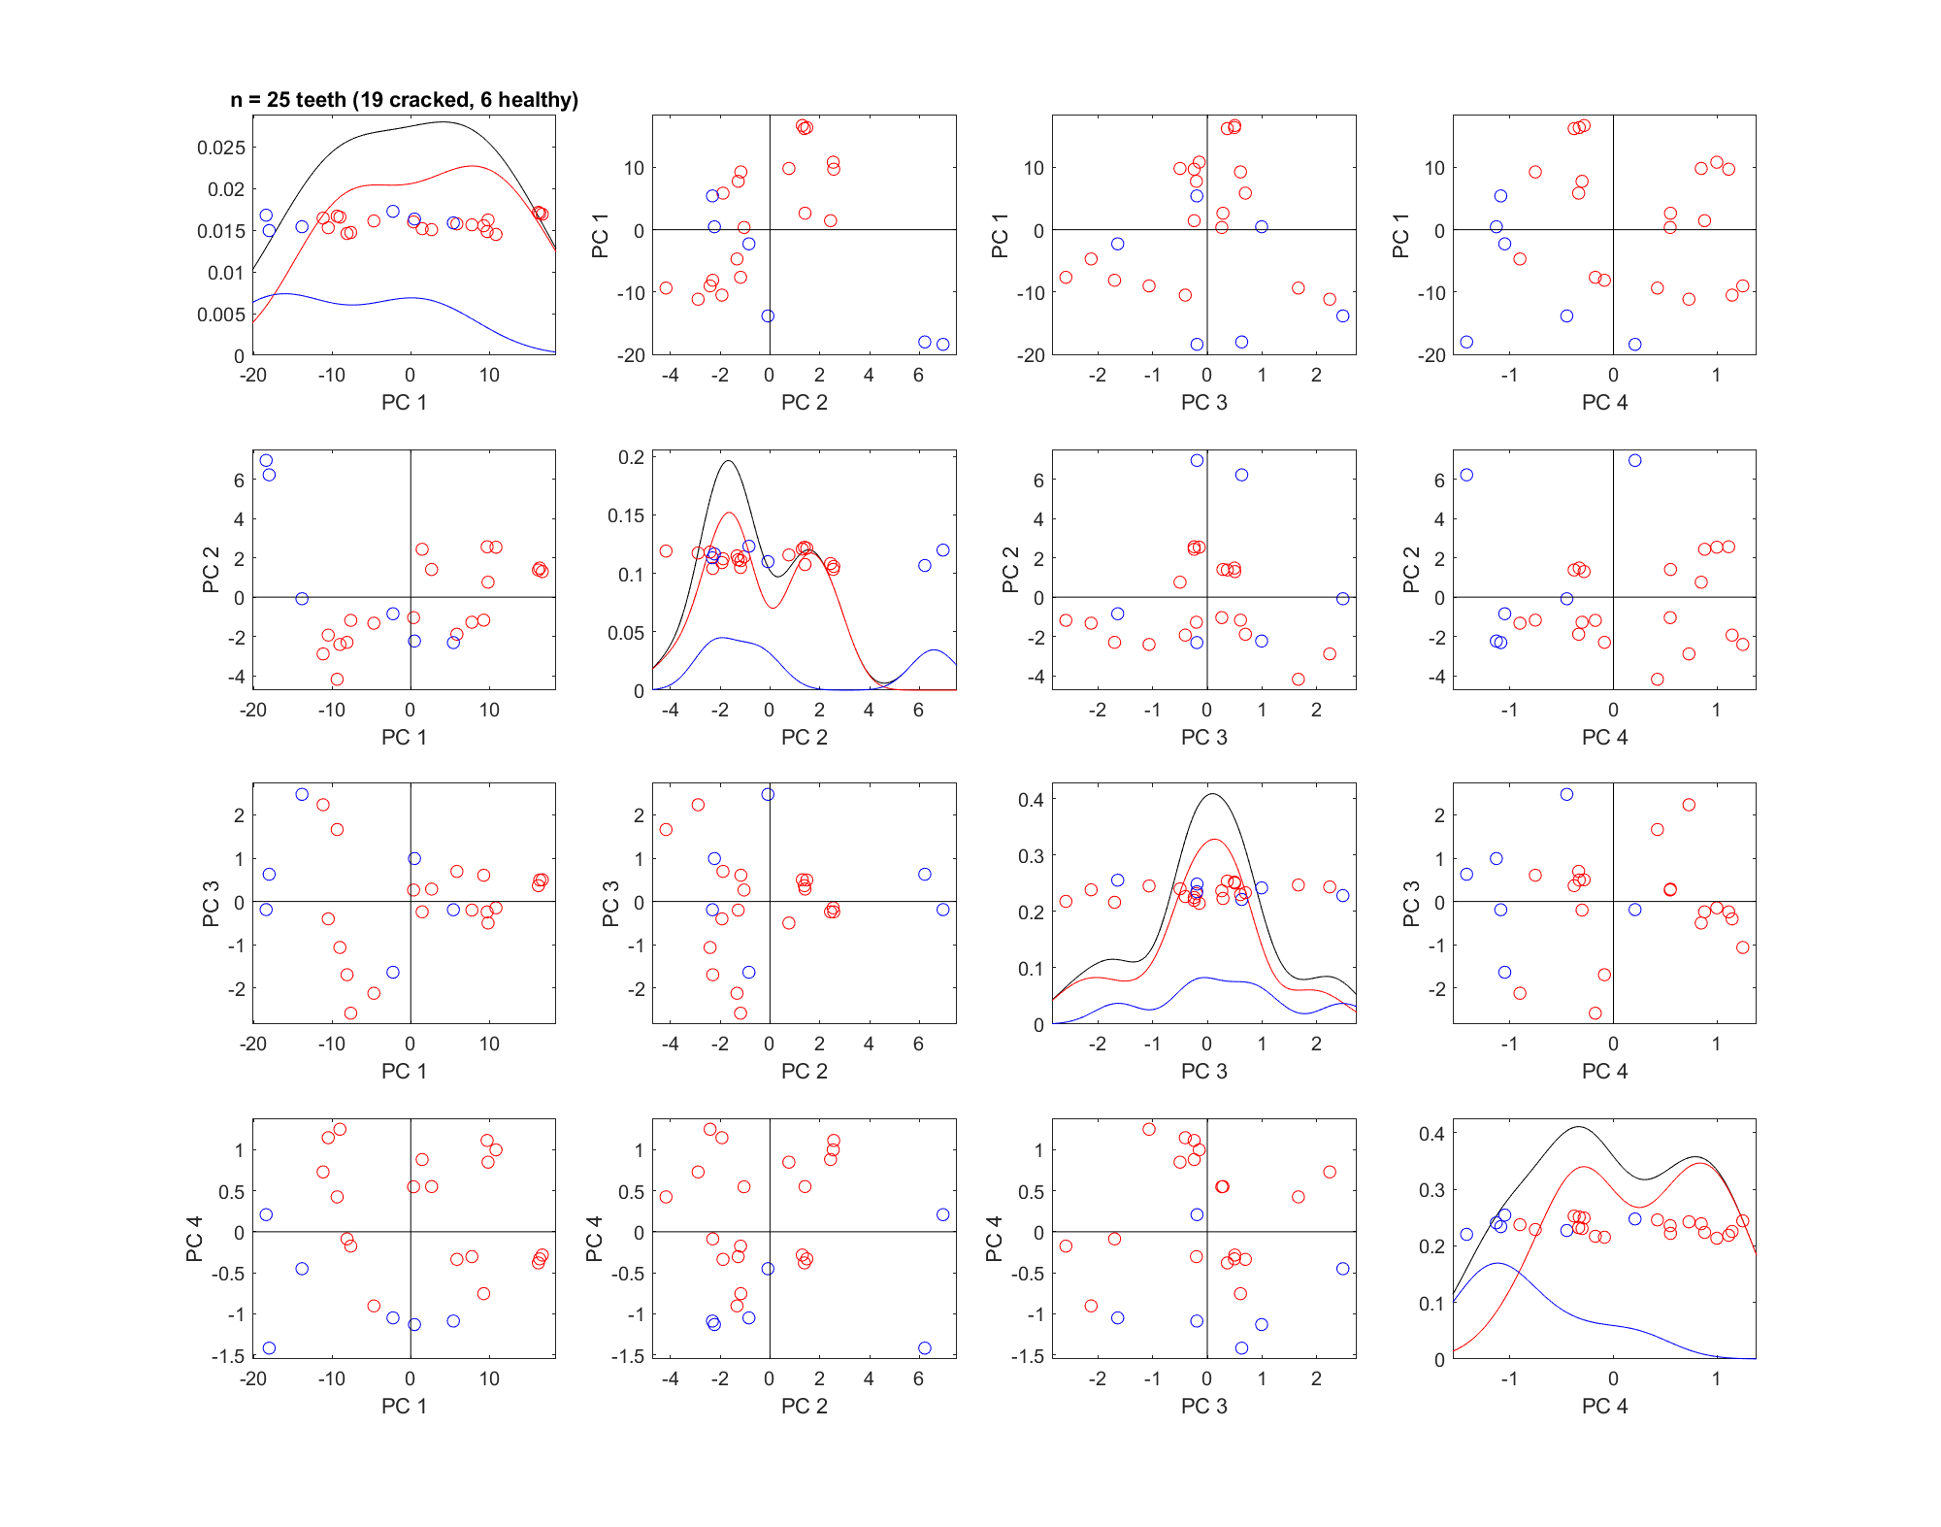

*Figure 4. For hr-CBCT, projection of data onto combinations of PC directions. Sub-density estimates in the 1-d distributions for cracked teeth (red), healthy teeth (blue), and all teeth (black) are on the diagonal. PC1 and PC4 combination shows improved separation of cracked (red) and healthy (blue) teeth.*

It should be noted that PCA requires each sample to have the same number of features. Since this is not the case for our dataset, we have been using the median number of features in each dataset as a cutoff. To be more specific, we only used the first 119 features (i.e. the median number of features) in the hr-CBCT dataset for samples that has more features, and zero-padded the samples with fewer features. An alternative way to solve this problem is to use a number of quantiles, which captures the trend of data as well as ensures the same number of features (i.e. quantiles) across samples. Here we used 100 quantiles (i.e. percentile) to represent the data (Supp. Fig.1). Using PCA, the modes of variation of quantiles (Supp. Fig. 2) showed very similar pattern to what we have seen in Fig. 3. This demonstrates the robustness of our analysis and supports our finding that hr-CBCT performs better in separating teeth condition than microCT.

1. *Hr-CBCT but not microCT shows separation of means between the two teeth conditions in later quantiles of data.*

To visualize a large number of variables and identify which ones contribute more to the structure of data as well as separating the groups, marginal distribution plot was used to visualize the property of quantiles (Fig. 5). Since we have 100 quantiles in total, we selected a representative subset of these quantiles to visualize. Here we focused on the mean of quantiles, since no additional information was found for this analysis applied on other statistics (eg. skewness, max, std, min).

Both microCT and hr-CBCT showed quantile means sorted in increasing order (Fig. 5 upper-left plot), as a result, the 1, 8, …93, 100th variable correspond to the 1, 8, …93, 100th quantiles, respectively. It should be noted that the first half of these averages are much smaller than the second half and the value increases dramatically towards later variables. This is consistent with what we have seen in the data (Fig. 2 and Supp. Fig. 1) where later quantiles have significantly larger values than early quantiles. For the first three rows of variables, their means for cracked (red dots) and healthy (black dots) teeth seemed to overlap for both microCT and hr-CBCT (Fig. 5). However, for the last row of variables, hr-CBCT showed some separation between the two teeth conditions, indicating that the largest 20 percentiles of the data might be more important in differentiating the teeth conditions. This is consistent with our intuition that cracks with larger sizes are more likely to be real cracks and to indicate the tooth condition correctly.

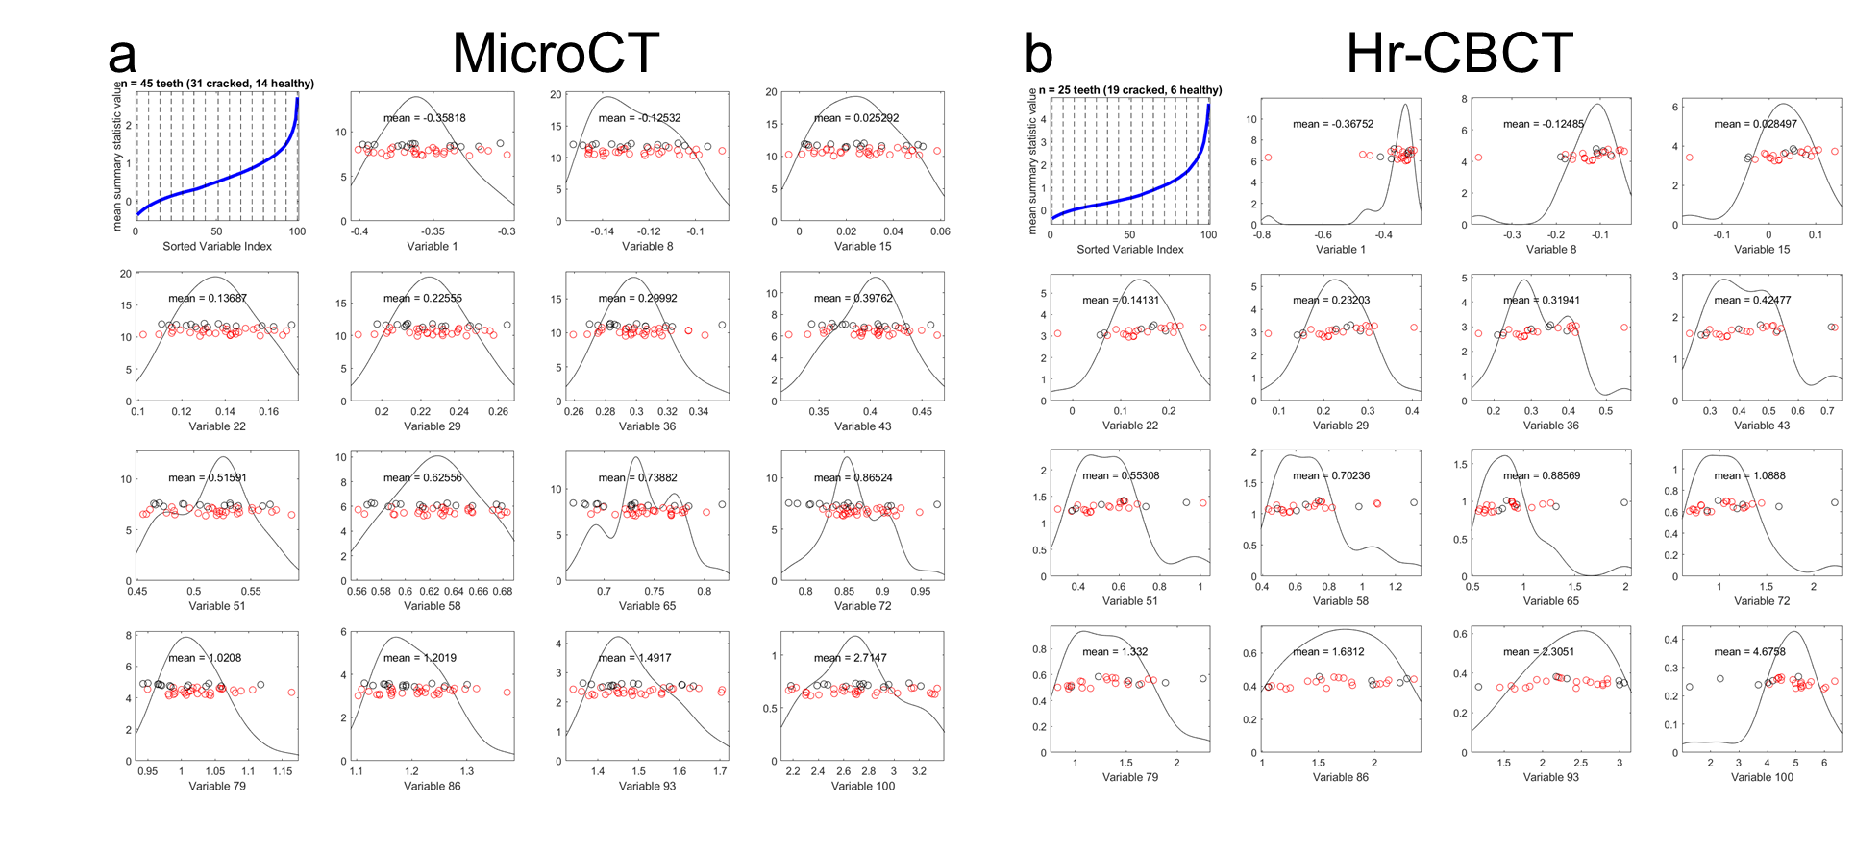

*Figure 5. Marginal distribution plot of quantiles for microCT (a) and hr-CBCT (b) for cracked (red) and healthy (black) teeth. The quantile means are shown in the upper left panel. Marginal distributions of a representative (equally spaced) set of quantiles, indicated as vertical dashed lines, appear in the remaining panels. MicroCT did not show separation of teeth conditions in all quantiles shown. Hr-CBCT showedr-CBCT but not microCT showed srate teeth conditionuantile representation of the data.itions suing DiProPerm. later quantiles are better at separating the two teeth conditions.*

1. *Quantitative testing revealed a significant separation of the two teeth conditions using hr-CBCT but not microCT*

In order to quantitatively test if the two teeth conditions are separable, we chose distance-weighted discrimination (DWD) as our detection method and validated the results with direction-projection-permutation (DiProPerm) hypothesis tests. DWD was developed as an improved version of support vector machines (SVM) for linear classification.7 DiProPerm8 is a permutation-based hypothesis test that assesses the chance that the observed degree of separation happened as a result of expected random variation. It was developed with DWD in mind as an area of application, but it represents a general framework of nonparametric hypothesis testing built to discern visually discovered typical and atypical behavior in high-dimensional settings.

Figure 6.a and b show the results of classifying cracked (red dots) and healthy (blue dots) in the microCT dataset, illustrated by projecting each tooth in the DWD and its orthogonal principal component directions (OPC1). Kernel density estimates of the data projected onto the DWD separating hyperplane show no clear separation between healthy and cracked teeth (Fig. 6.b, left). Further, DiProPerm test confirms no significance separation between the two groups (Fig. 6.b, right, *p* = 0.74). Figure 6.c and d show the results of classification in the hr-CBCT dataset. Unlike in microCT dataset, it shows appropriate separation of cracked versus healthy teeth using the same plane projection (Fig. 6.d, left). DiProPerm also showed a significant separation result (Fig. 6.d, right, *p* = 0.026) even for this small sample size. This confirms quantitatively that the crack distribution data derived from hr-CBCT, but not microCT, is able to separate teeth conditions.

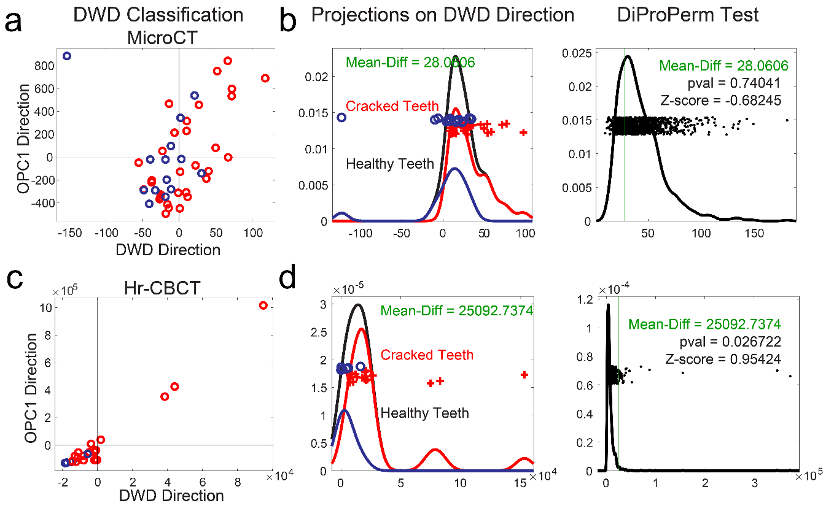

*Figure 6. DWD classification of teeth conditions for microCT (a) and hr-CBCT (c). Each data sample is projected onto the DWD direction as well as its orthogonal principle component 1 (OPC1) direction. Kernel density estimates of the data projections onto the DWD separating hyperplane and permutation tests using DiProPerm for microCT (b) and hr-CBCT (d). Demonstrates a significant separation of the two teeth conditions using hr-CBCT but not microCT.*

The same analysis was applied to the percentile representation of this data, but neither microCT nor hr-CBCT showed significant separation of the two teeth conditions using DiProPerm (Supp. Fig. 4). This might suggest that for healthy teeth, it is important to take into account the fact that they have fewer cracks (using feature number cutoff as in Fig. 6) which is not reflected in the quantile representation of the data (Supp. Fig. 4).

**Discussion**

Results with this data suggest that the combining hr-CBCT and advanced analysis pipeline can achieve good detection of cracked teeth. It can be applied to hr-CBCT clinically when the images are not over-processed (i.e. without smoothing filter). Further thresholding for the presence of large connected voxels can help flag potential cracks. This will provide the clinician additional visual information and confidence to determine if the highlighted area is a crack or not.

It needs to be noted that the hr-CBCT data was synthetic since the hr-CBCT dataset without filter is not available for this project. In the future, it would be ideal to acquire original images without additional filters and run through the same pipeline to compare the results. In addition, since different settings and datasets were used, no direct comparison was made between the two imaging methods. To quantitively compare the two methods, it would be important to control for other factors (eg. the setting for teeth presentation) and ideally using the same teeth samples. At last, the sample size for hr-CBCT is relatively low. There are only 6 samples of healthy control teeth, but there are many more number of features. A larger sample size would be better for identify important features in distributions and would be more robust to outliers.

**Appendix**

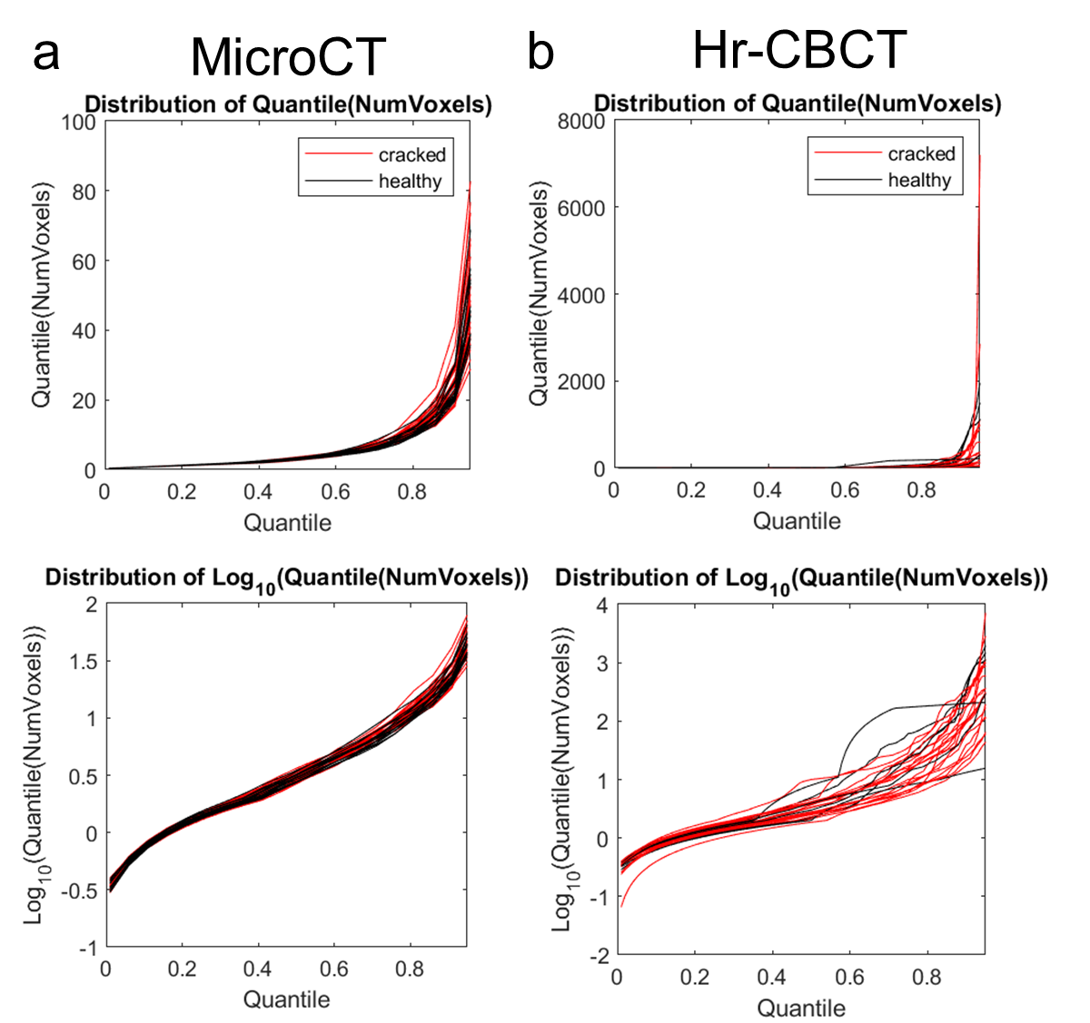

*Supplemental Figure 1. Distribution of 100 quantiles of crack sizes for microCT (a) and hr-CBCT (b). For each dataset, the top plot displays the raw quantile data and the bottom plot displays data in logarithmic scale. For both datasets, logarithmic scale provides better visualization of the distribution. Hr-CBCT shows qualitatively better separation of quantile distributions between cracked and healthy teeth. (Relate to Fig. 2)*

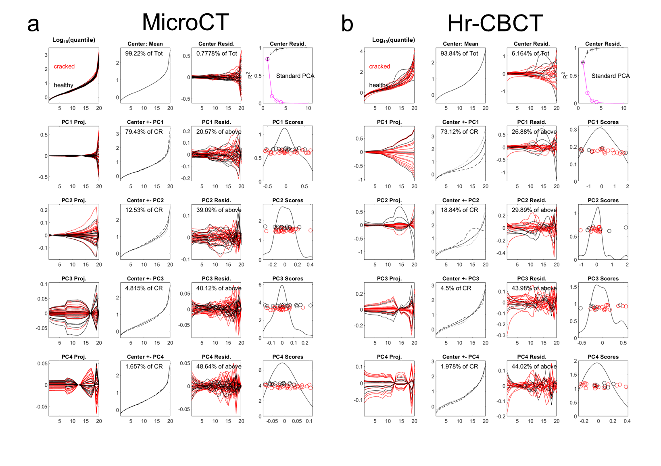

*Supplemental Figure 2. Visualization of modes of variation using principal component analysis for microCT (a) and hr-CBCT (b) for quantiles. Each line in column 1 and 3, and each dot in column 4 represents a tooth sample, either cracked (red) or healthy (black). In hr-CBCT but not micro-CT, there is some separation between cracked vs. healthy teeth in the principal component directions. (Relate to Fig. 3)*

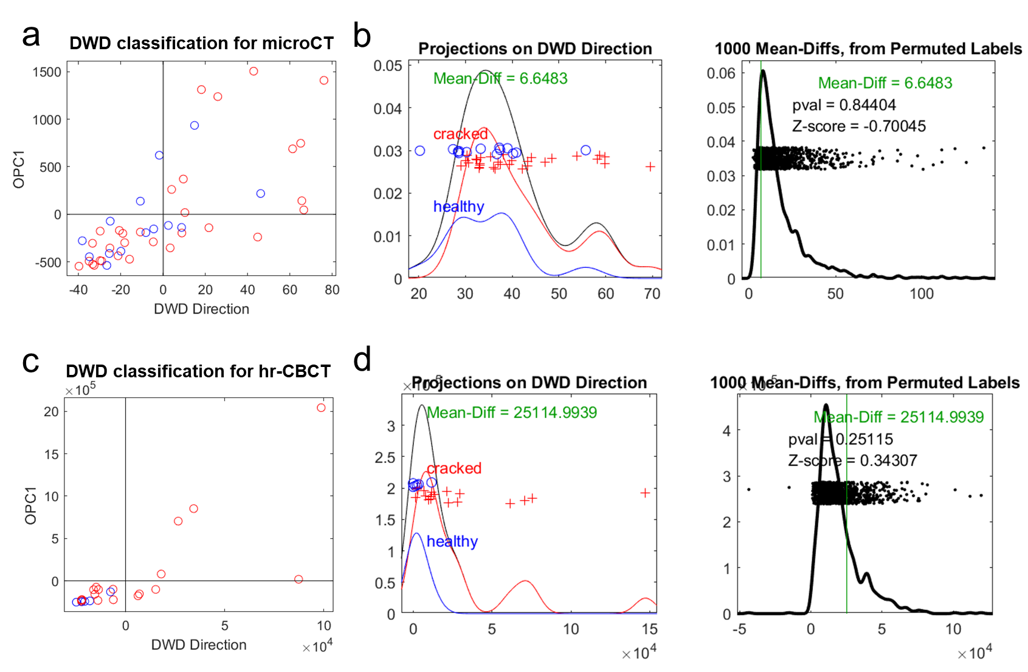

*Supplemental Figure 3. DWD classification for microCT (a) and hr-CBCT (c) using quantile data. Each data sample is projected onto the DWD direction as well as its orthogonal principle component 1 (OPC1) direction. Kernel density estimates of the data projections onto the DWD separating hyperplane and permutation tests using DiProPerm for microCT (b) and hr-CBCT (d). No significant separation of the two groups using either hr-CBCT or microCT.*

**Reference**

1 Lynch, C. D. & McConnell, R. J. The cracked tooth syndrome. *Journal (Canadian Dental Association)* **68**, 470-475 (2002).

2 Ricucci, D., Siqueira Jr, J. F., Loghin, S. & Berman, L. H. The cracked tooth: histopathologic and histobacteriologic aspects. *Journal of endodontics* **41**, 343-352 (2015).

3 Portman-Lewis, S. An analysis of the out-of-hours demand and treatment provided by a general dental practice rota over a five-year period. *Primary Dental Care* **14**, 98-104 (2007).

4 Vicory, J. *et al.* *Dental microfracture detection using wavelet features and machine learning*. Vol. 11596 MI (SPIE, 2021).

5 Shah, H. *et al.* Automatic quantification framework to detect cracks in teeth. *Proc SPIE Int Soc Opt Eng* **10578**, 105781K, doi:10.1117/12.2293603 (2018).

6 Marron, J. S. Object Oriented Data Analysis. doi:<https://marron.web.unc.edu/stor-881-object-oriented-data-analysis-fall-2019/> (2019).

7 Marron, J. S., Todd, M. J. & Ahn, J. Distance-Weighted Discrimination. *Journal of the American Statistical Association* **102**, 1267-1271, doi:10.1198/016214507000001120 (2007).

8 Wei, S., Lee, C., Wichers, L. & Marron, J. S. Direction-Projection-Permutation for High-Dimensional Hypothesis Tests. *Journal of Computational and Graphical Statistics* **25**, 549-569, doi:10.1080/10618600.2015.1027773 (2016).